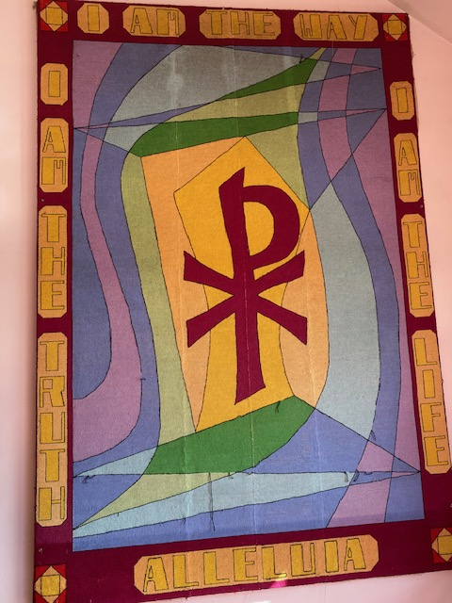
For some time now St Johns Church, Glenorchy has been hosting a tapestry on the back wall, which needs some repair work. After we enlisted the help of the Diocesan Archivist we have discovered this is part of a group of textile works made for St Mary’s Cathedral in 1976-77 by a group of “Tapestry Ladies” of the Catholic Women’s League.

From The Australian Women’s Weekly:
THEY WORE OUT 24 PACKETS OF NEEDLES
Mrs Kath Nash, of New Town, was pictured in front of “our” tapestry, which was the largest of the group of tapestries, whose designs were chosen by the Most Reverend Sir Guilford Young, KBE. The three largest tapestries adorned the cathedral altar and 24 packets of tapestry needles were broken in their creation.
The main image is the Chi Rho, an early symbol for Christ, since the time of the Emperor, Constantine. (Easter 2023)

